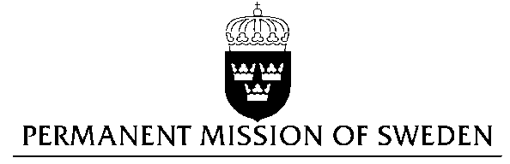
UN Human Rights Council

UPR 27th session

Statement by Sweden in the interactive dialogue on Finland
(1 min 30 secs)

Mr President,

Sweden wishes to welcome the delegation of Finland.

Sweden recommends the Government of Finland:

- To increase its funding to actors engaged in combatting violence and sexual abuse of women.

- To revise the Trans Act by abolishing the need for sterilization, other medical treatment, and a mental health diagnosis, as requirements for a person’s legal recognition of their gender identity and ensure that medical procedures performed on intersex infants and children take into account the best interest of the child.

Finland is ranked as one of the most gender equal countries in the world. However, domestic violence and sexual abuse against women remains widespread.

Finland is a party to the Istanbul convention but concerns have been raised about the resources devoted to implement it. For instance, the number of safe shelter places is reportedly around 120, whereas the Council of Europe Convention recommends about 500 places for a country the size of Finland. The number of crisis centers specializing in helping victims of rape is also very limited. Rape is narrowly defined and judged according to the degree of violence, rather than the act of sexual abuse itself.

Finland has an extensive legislation against discrimination. Provisions to prohibit discrimination based on gender identity or gender expression were added to the Equality Act, and came into force in January 2015. However, transgender persons and intersex children continue to face discrimination. According to the Act on Legal Recognition of the Gender of Transsexuals, the gender registered at birth can only be changed if the person presents a medical statement certifying that they, among other things, have been sterilized or are infertile. Intersex infants and children are still subjected to medical procedures for social or cosmetic purposes.

I thank you Mr President

